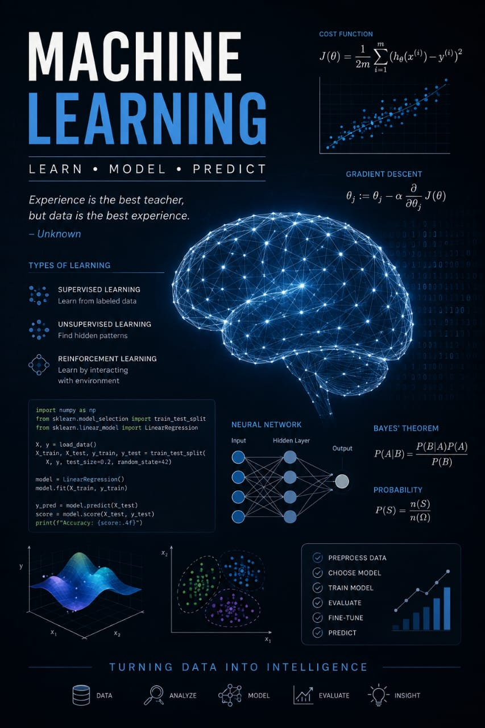

Machine Learning

By Jawad Jammoul

